

# Name: Apurba Koirala

# Reg no: 22BCE3799

# Subject Code: BCSE204P

# Course Title: Design and Analysis of Algorithms Lab

# Lab Slot: L39 + L40

# Guided by: Dr. IYAPPAN P

# Lab Assessment 2

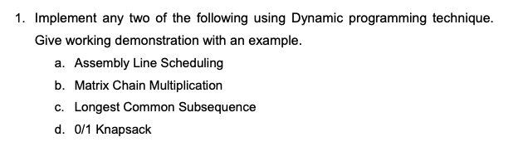

Solution:

b. Matrix Chain Multiplication

Algorithm:

1. Input n: Take input for the number of matrices.
2. Input n+1 dimensions: Store dimensions in an array arr.
3. Initialize DP table: Create a 2D array dp of size n × n with all values set to 0.
4. Base case: Set dp[i][i] = 0 since a single matrix requires no multiplication.
5. Iterate over chain length len: Loop from 2 to n to consider different sub-chain lengths.
6. Loop over starting index i: Iterate from 0 to n - len to define matrix ranges.
7. Compute end index j: Set j = i + len for the ending matrix in the current range.
8. Initialize dp[i][j] = INT_MAX to store the minimum multiplication cost.
9. Try all possible partitions k: Loop k from i+1 to j-1 to find the optimal split.
10. Compute multiplication cost using the formula:

dp[i][j] = min(dp[i][j], dp[i][k] + dp[k][j] + arr[i] * arr[k] * arr[j])

1. Update dp[i][j] with the minimum cost found for multiplying matrices from i to j.
2. Return dp[0][n-1] as the final result, which contains the minimum multiplication cost.

Code:

#include <iostream>

#include <vector>

using namespace std;

int matrixMultiplication(vector<int> &arr) {

int n = arr.size();

vector<vector<int>> dp(n, vector<int>(n, 0));

for (int len = 2; len < n; len++) {

for (int i = 0; i < n - len; i++) {

int j = i + len;

dp[i][j] = INT_MAX;

for (int k = i + 1; k < j; k++) {

int cost = dp[i][k] + dp[k][j] + arr[i] * arr[k] * arr[j];

dp[i][j] = min(dp[i][j], cost);

}

}

}

return dp[0][n - 1];

}

int main() {

int n;

cout << "Enter the number of matrices: ";

cin >> n;

vector<int> arr(n + 1);

cout << "Enter the " << n + 1 << " dimensions of matrices: ";

for (int i = 0; i <= n; i++) {

cin >> arr[i];

}

cout << "Minimum cost of matrix multiplication: " << matrixMultiplication(arr) << endl;

return 0;

}

Input:

(Same problem as class)  
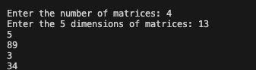

Output:



Time Complexity Analysis:

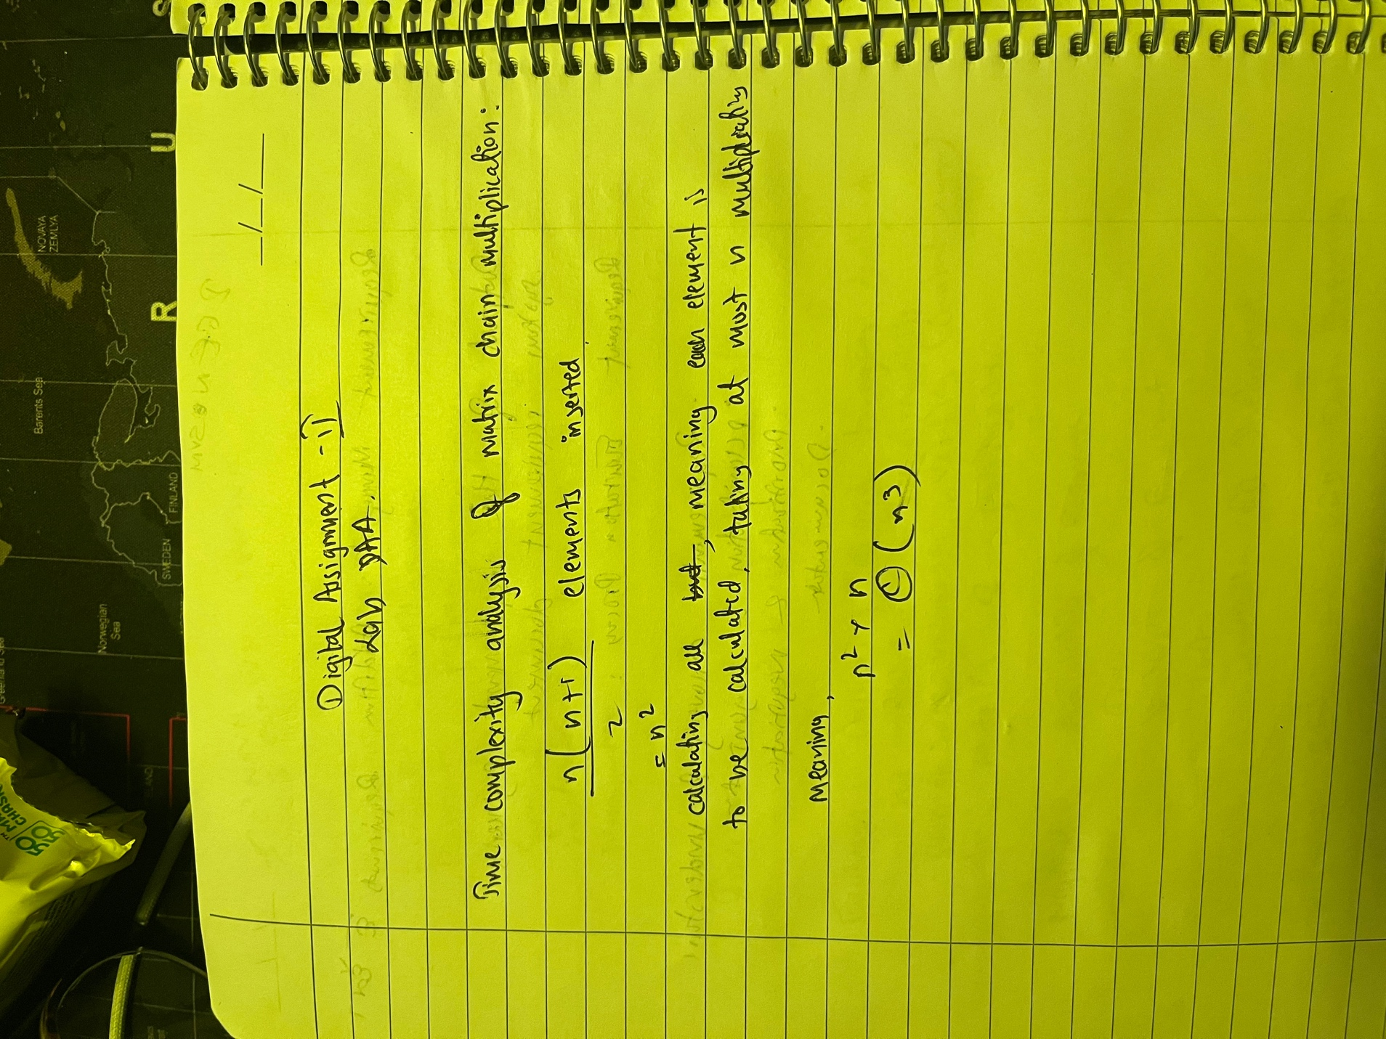

c. Longest Common Subsequence

Solution:

Algorithm

1. Take input strings s1 and s2.
2. Create a 2D vector called memo with dimensions (length of s1 + 1) by (length of s2 + 1) and initialize all values to -1.
3. Define a recursive function lcs that takes s1, s2, their lengths, and the memo table as input.
4. If either string has length 0, return 0.
5. If the value at memo[m][n] is not -1, return that value to avoid redundant calculations.
6. If the last characters of both strings match, add 1 to the result of lcs called on the remaining substrings.
7. If the last characters do not match, return the maximum value between lcs called on (m, n-1) and (m-1, n).
8. Store the computed value in memo[m][n] before returning it.
9. Print the result of calling lcs on the input strings.

Code:

#include <iostream>

#include <vector>

using namespace std;

int lcs(string &s1, string &s2, int m, int n, vector<vector<int>> &memo) {

if (m == 0 || n == 0)

return 0;

if (memo[m][n] != -1)

return memo[m][n];

if (s1[m - 1] == s2[n - 1])

return memo[m][n] = 1 + lcs(s1, s2, m - 1, n - 1, memo);

return memo[m][n] = max(lcs(s1, s2, m, n - 1, memo), lcs(s1, s2, m - 1, n, memo));

}

int main() {

string s1;

string s2;

cout<< "Enter first string: ";

cin>>s1;

cout<< "\nEnter second string: ";

cin>>s2;

cout<<"\n";

int m = s1.length();

int n = s2.length();

vector<vector<int>> memo(m + 1, vector<int>(n + 1, -1));

cout << lcs(s1, s2, m, n, memo) << endl;

return 0;

}

Input:

(Same as class)

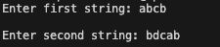

Output:



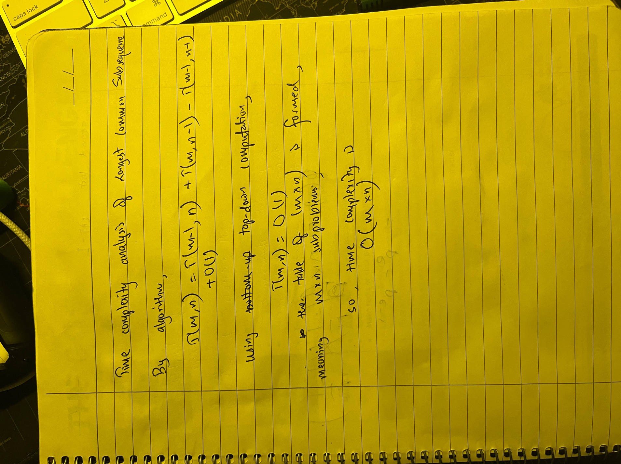Time complexity analysis:



Solution:

Algorithm

1. **Start placing queens row by row.**
2. **Check if the column and diagonals are safe.**
3. **Place a queen and mark the column and diagonals.**
4. **Move to the next row recursively.**
5. **If all queens are placed, return the position.**
6. **If placement fails, backtrack and try another column.**
7. **If no solution is found, return -1.**

**Code:**

#include <iostream>

#include <vector>

using namespace std;

int placeQueens(int i, vector<int> &cols, vector<int> &leftDiagonal,

vector<int> &rightDiagonal, vector<int> &cur) {

int n = cols.size();

if(i == n) return 1;

for(int j = 0; j < n; j++){

if(cols[j] || rightDiagonal[i + j] ||

leftDiagonal[i - j + n - 1])

continue;

cols[j] = 1;

rightDiagonal[i+j] = 1;

leftDiagonal[i - j + n - 1] = 1;

cur.push_back(j+1);

if(placeQueens(i + 1, cols, leftDiagonal, rightDiagonal, cur))

return 1;

cur.pop_back();

cols[j] = 0;

rightDiagonal[i+j] = 0;

leftDiagonal[i - j + n - 1] = 0;

}

return 0;

}

vector<int> nQueen(int n) {

vector<int> cols(n, 0);

vector<int> leftDiagonal(n*2, 0);

vector<int> rightDiagonal(n*2, 0);

vector<int> cur;

if(placeQueens(0, cols, leftDiagonal, rightDiagonal, cur))

return cur;

else return {-1};

}

int main() {

int n;

cout<<"Enter Number of Queens: ";

cin>>n;

cout<<"\n";

vector<int> ans = nQueen(n);

for(auto i: ans){

cout << i << " ";

}

return 0;

}

**Input:**



**Output:**



**Time Complexity Analysis:**

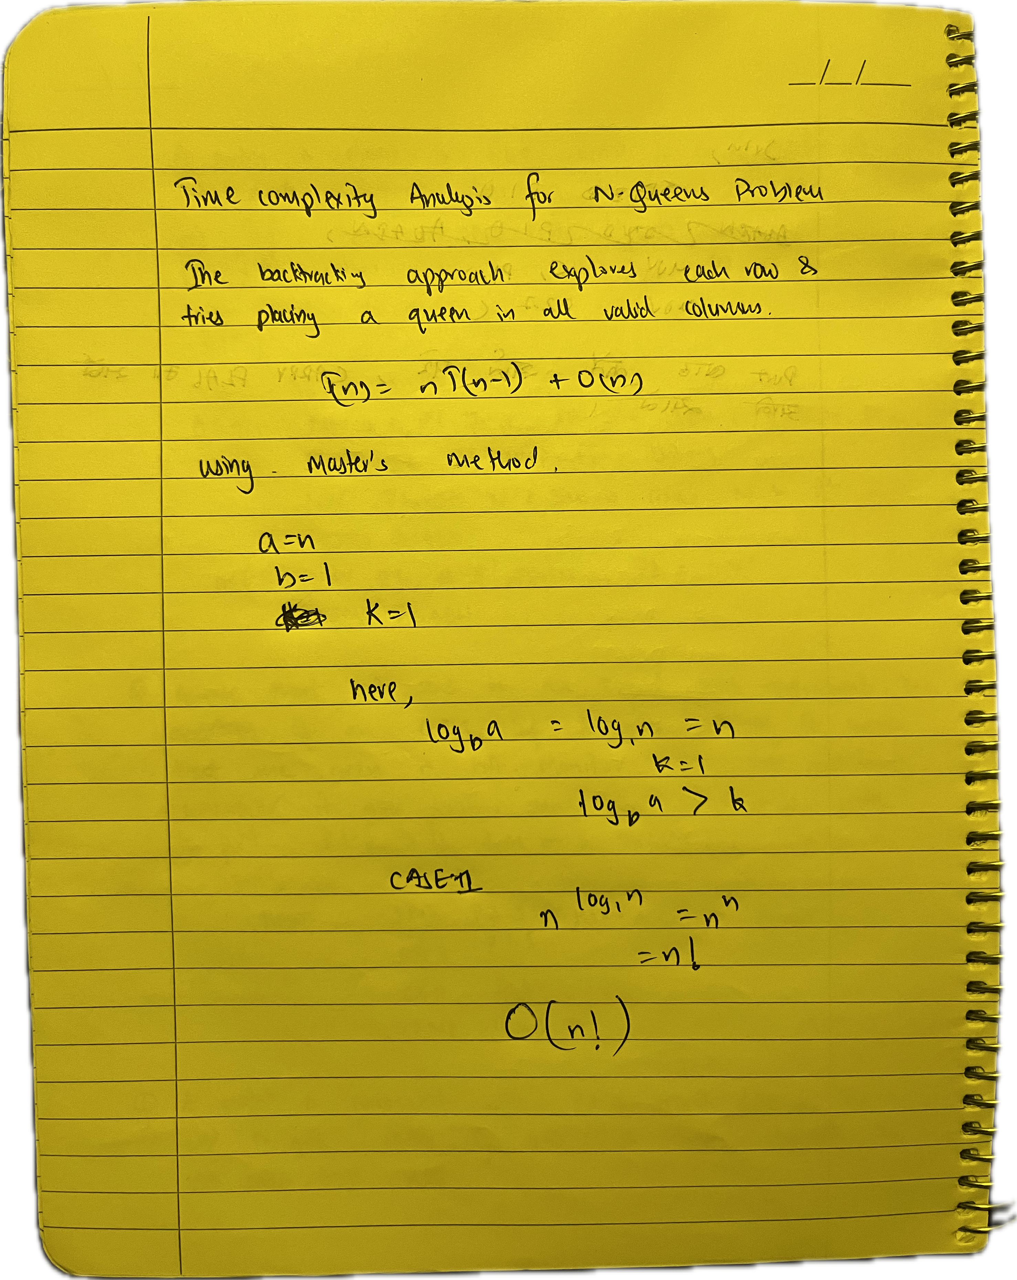

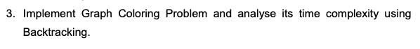

**Solution:**

**Algorithm:**

1. Take number of vertices, adjacency matrix, and number of colors as input.
2. Initialize a color array with 0.
3. Define a function to check if a color assignment is valid.
4. Use recursion to assign colors to vertices.
5. If all vertices are colored, print the solution.
6. If no valid coloring is found, return failure.

**Code:**

#include <iostream>

#include <vector>

using namespace std;

bool isSafe(int v, vector<vector<int>> &graph, vector<int> &color, int c, int V) {

for (int i = 0; i < V; i++) {

if (graph[v][i] && color[i] == c)

return false;

}

return true;

}

bool graphColoringUtil(vector<vector<int>> &graph, int m, vector<int> &color, int v, int V) {

if (v == V)

return true;

for (int c = 1; c <= m; c++) {

if (isSafe(v, graph, color, c, V)) {

color[v] = c;

if (graphColoringUtil(graph, m, color, v + 1, V))

return true;

color[v] = 0;

}

}

return false;

}

bool graphColoring(vector<vector<int>> &graph, int m, int V) {

vector<int> color(V, 0);

if (!graphColoringUtil(graph, m, color, 0, V)) {

cout << "Solution does not exist" << endl;

return false;

}

cout << "Solution Exists: Assigned Colors: ";

for (int i = 0; i < V; i++)

cout << color[i] << " ";

cout << endl;

return true;

}

int main() {

int V, m;

cout << "Enter the number of vertices: ";

cin >> V;

vector<vector<int>> graph(V, vector<int>(V, 0));

cout << "Enter the adjacency matrix (" << V * V << " values row-wise):" << endl;

for (int i = 0; i < V; i++)

for (int j = 0; j < V; j++)

cin >> graph[i][j];

cout << "Enter the number of colors: ";

cin >> m;

graphColoring(graph, m, V);

return 0;

}

**Input:**

**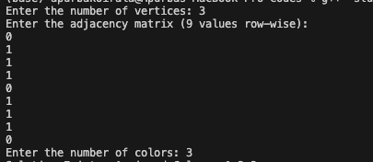  
  
Output:**



**Time Complexity Analysis:**

